4.57: In this situation, the x-component of force depends explicitly on the y-component of position. As the y-component of force is given as an explicit function of time, 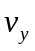 and y can be found as functions of time. Specifically, 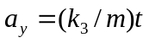, so 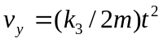 and 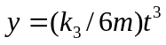, where the initial conditions 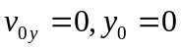 have been used. Then, the expressions for 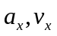 and x are obtained as functions of time:
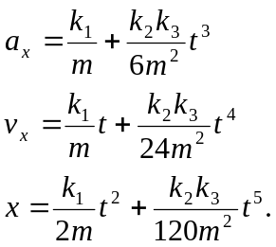
In vector form,
